1,034% Video View Growth for a Michigan PI Firm

SOCIAL

Results that speak for themselves

Key Stats & Results


14,300 views on a single authority-driven Instagram stitch

Increased follower acquisition directly from strategic posts

Behind the transformation

How a PI Law Firm Increased Social Engagement by 182%
When this Michigan-based personal injury law firm leaned into culture, moved quickly, and applied a real legal social strategy, the numbers followed. By combining timely commentary, authority-driven hooks, and strong execution, Rankings.io transformed the firm’s organic social performance across Instagram and TikTok.

FROM CHALLANGES TO SUCCESS


How the Firm Started: The Challenge
This personal injury law firm built its reputation on strong client communication, responsiveness, and a people-first approach, values that set it apart in a highly competitive Michigan market.
When the firm partnered with Rankings.io, the objective was clear: build real authority on social media while generating measurable engagement and visibility.
Like many personal injury firms, they had legal expertise but needed a repeatable, platform-native strategy that could translate that authority into attention and growth.
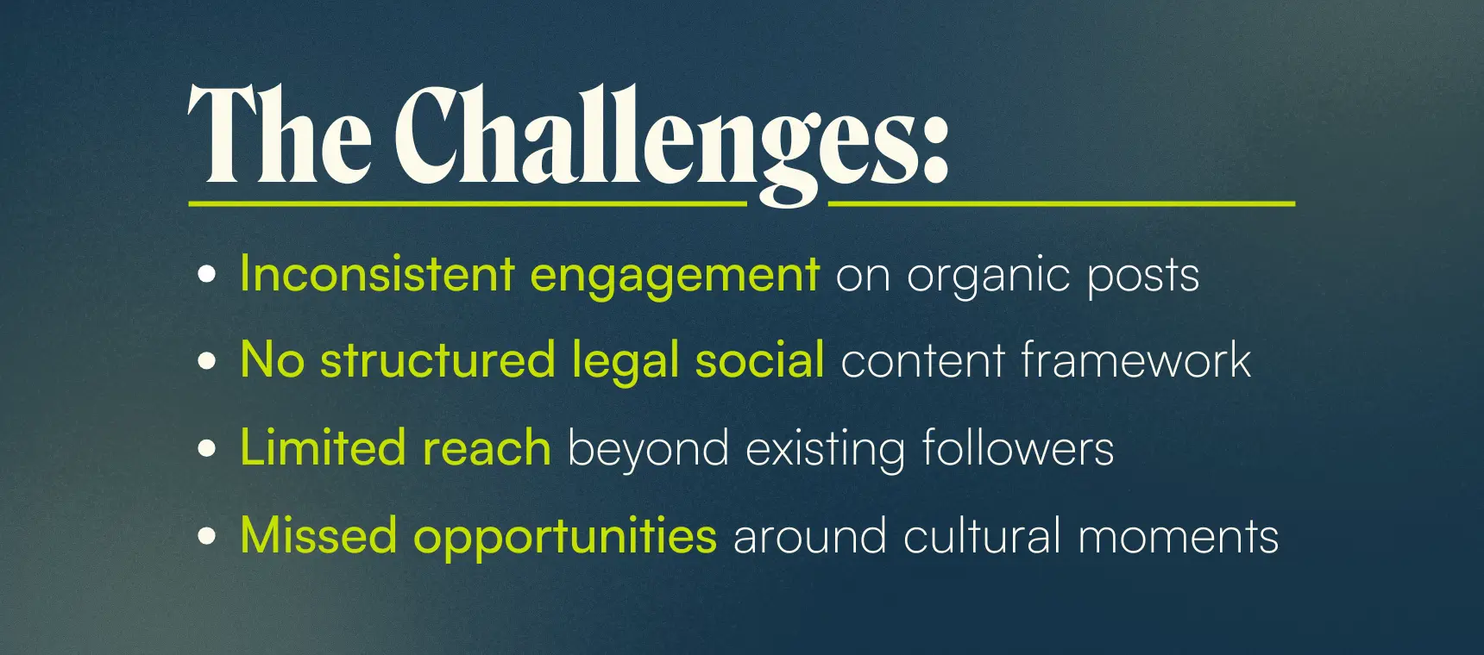



How We Did It: The Strategy
Rankings.io deployed a comprehensive organic social strategy designed specifically for personal injury law firms.
We built our approach on social listening, identifying content gaps, and positioning the attorney as a trusted legal voice in conversations the audience was already having.

1. Audience-Led Content & Social Listening
We analyzed trending legal conversations and high-performing video formats to understand what users actively searched for on social media, then created content that answered those questions.
Instead of limiting topics to only traditional personal injury scenarios, we intentionally stepped into broader, high-interest discussions to expand reach and authority.
A police car accident stitch post is a strong example.
While this type of case sits slightly outside of what many personal injury firms typically highlight, it addresses a topic social audiences were highly curious about and struggling to find a clear legal context for.
By stepping outside the firm’s usual comfort zone, we:
- Filled an informational gap in the market
- Positioned the attorney as a broad, credible legal authority
- Reached a significantly wider audience
Results:
- 14,300 views
- 182% higher engagement than average
- 1,034% higher impressions/views than average
- 41% watch time
- 3 new followers
This wasn’t reactive content. We built audience-first legal content around real demand.
The same strategy applied to a Super Bowl reactive video.
While the firm’s direct practice scope does not involve Super Bowl advertising, the cultural moment created massive search and conversation volume.
By delivering conversational, relatable legal insight, the content:
- Entered a high-volume cultural conversation
- Filled a knowledge gap on social media
- Dramatically expanded reach beyond the firm’s typical benchmarks
Results:
- 1,500 views
- 3,671% higher impressions than average
- 12 shares
- 2 saves
- 5 new followers

2. Authority Positioning Through “You-Centric” Content
We built every post around the audience’s questions — not the firm’s services.
This shift from firm-focused messaging to user-focused legal education allowed the attorney to become part of the daily social conversation, not just another brand publishing updates.
Key elements included:
- Conversational, relatable legal commentary
- Clear explanations of complex topics
- Content framed around what the viewer needs to know
- Broad legal authority positioning beyond a single case type

3. Platform-Native Optimization & Social SEO
Once Rankings.io identified the right topics, we optimized execution for maximum performance on each platform:
- Platform-specific video structures
- Strong first-second hooks
- Captions built with social SEO principles
- Intentional pacing for retention
- Consistent authority-driven branding
These refinements amplified the impact of the audience-first strategy, directly increasing impressions, engagement, and follower growth.



Before & After
After implementing a structured organic legal social strategy tailored for personal injury law firms, the firm achieved measurable performance improvements across key content pieces.
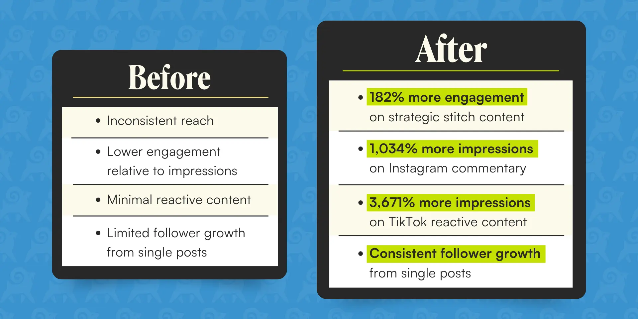

Key Wins
- 14,300 views on a single authority-driven Instagram stitch
- 41% watch time on legal commentary content
- 3,671% lift in impressions from cultural reactive content
- Increased follower acquisition directly from strategic posts

Ready to Grow Your Firm?
This case study shows what happens when legal expertise meets a real social media strategy.
Through our Social Media Marketing Services for Lawyers, we help firms build authority, increase engagement, and generate measurable visibility in today’s attention-driven legal market.
At Rankings.io we specialize in growth for personal injury law firms, combining proven search strategies with high-performance organic social execution.
Our integrated approach ensures your firm builds authority wherever potential clients pay attention.

